Sermon Translation: How to Translate Church Services Live
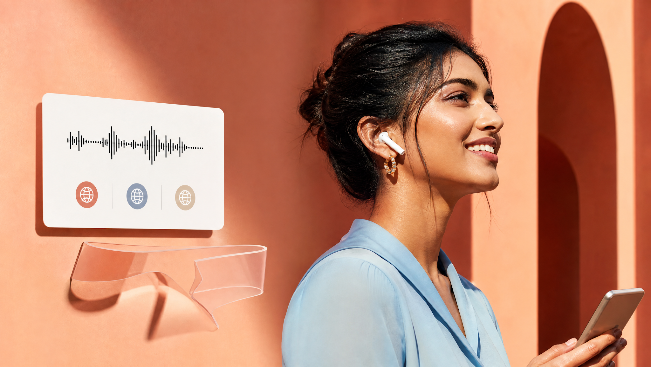
It's 9:40 on a Sunday morning. A visitor asks your greeter where the translation headsets are. About 21.7% of people age five and older speak another language at home, according to Census Bureau figures for 2018 to 2022. Someone in your pews may be waiting. So how do you translate a sermon live without a closet full of receivers?
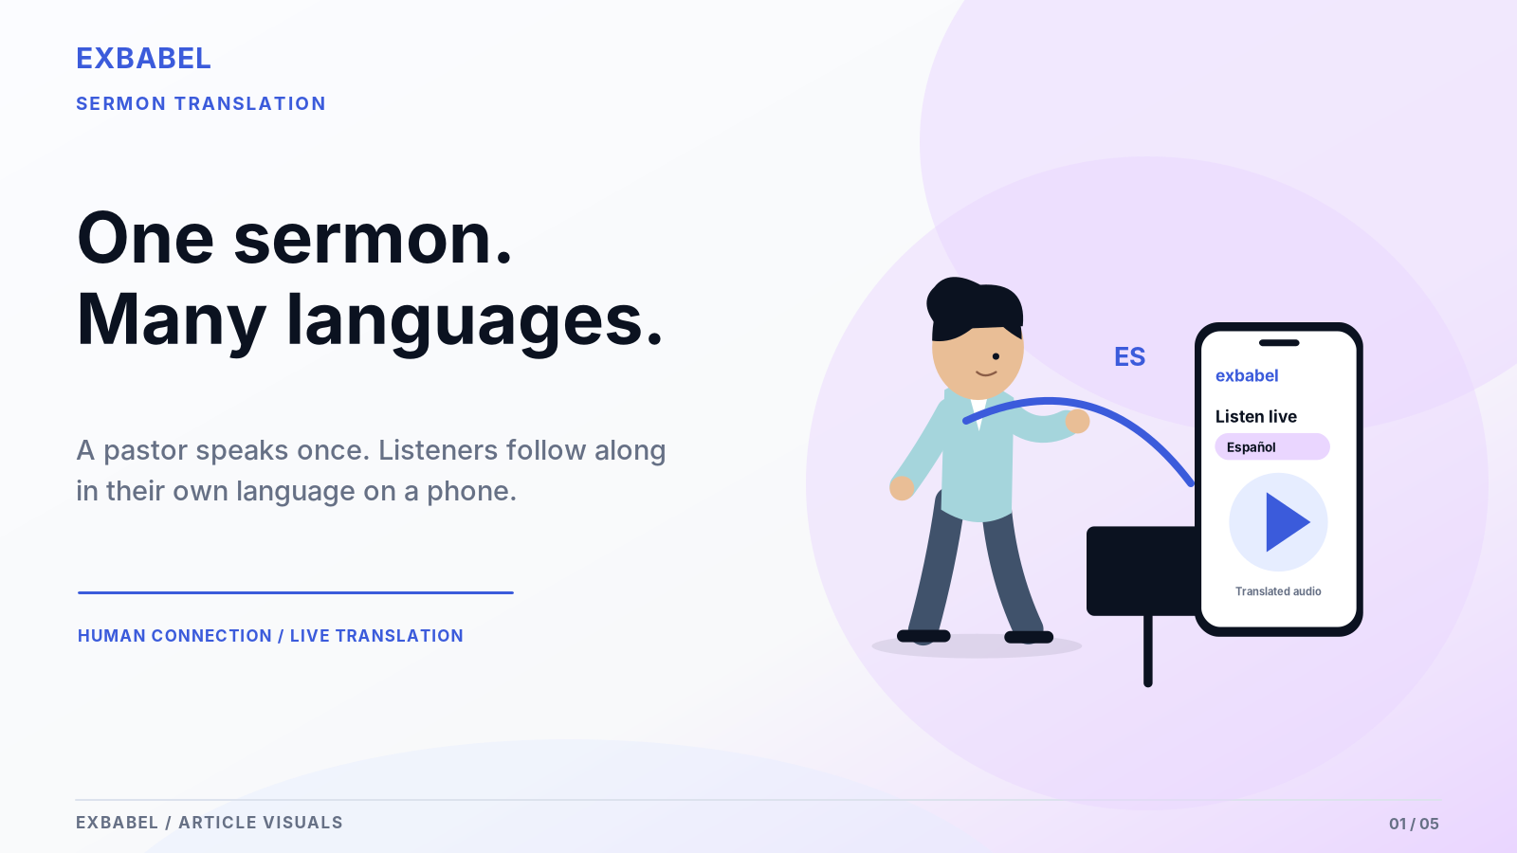

How Do You Translate a Church Service Live?
You send a clean copy of the pastor's voice into a translation tool, then let listeners pick a language on their own phones. Three routes work: a human interpreter with receivers, AI audio on phones or captions. Most problems start earlier than the software: a muddy microphone, a mix full of drums, a weak connection or a silent browser. This guide follows the signal step by step.

Key Takeaways
- Start with a clean, speech-only copy of the pastor's microphone. Everything else depends on it.
- Pick the route by your congregation: interpreter and receivers, AI audio on phones or captions.
- Treat the five-minute test as the real purchase decision. Run it before Sunday.
- Keep a human fallback ready for dropped connections and for sensitive moments.
- Run the five-minute test on your own gear, because every room behaves differently.
Let's start with the three routes, because each one changes what you buy and who does the work.

Quick Answer: Three Ways to Translate a Live Sermon
A sermon can cross a language gap three ways. Some churches run two at once. Here's a cheat sheet first, then a closer look at each route.
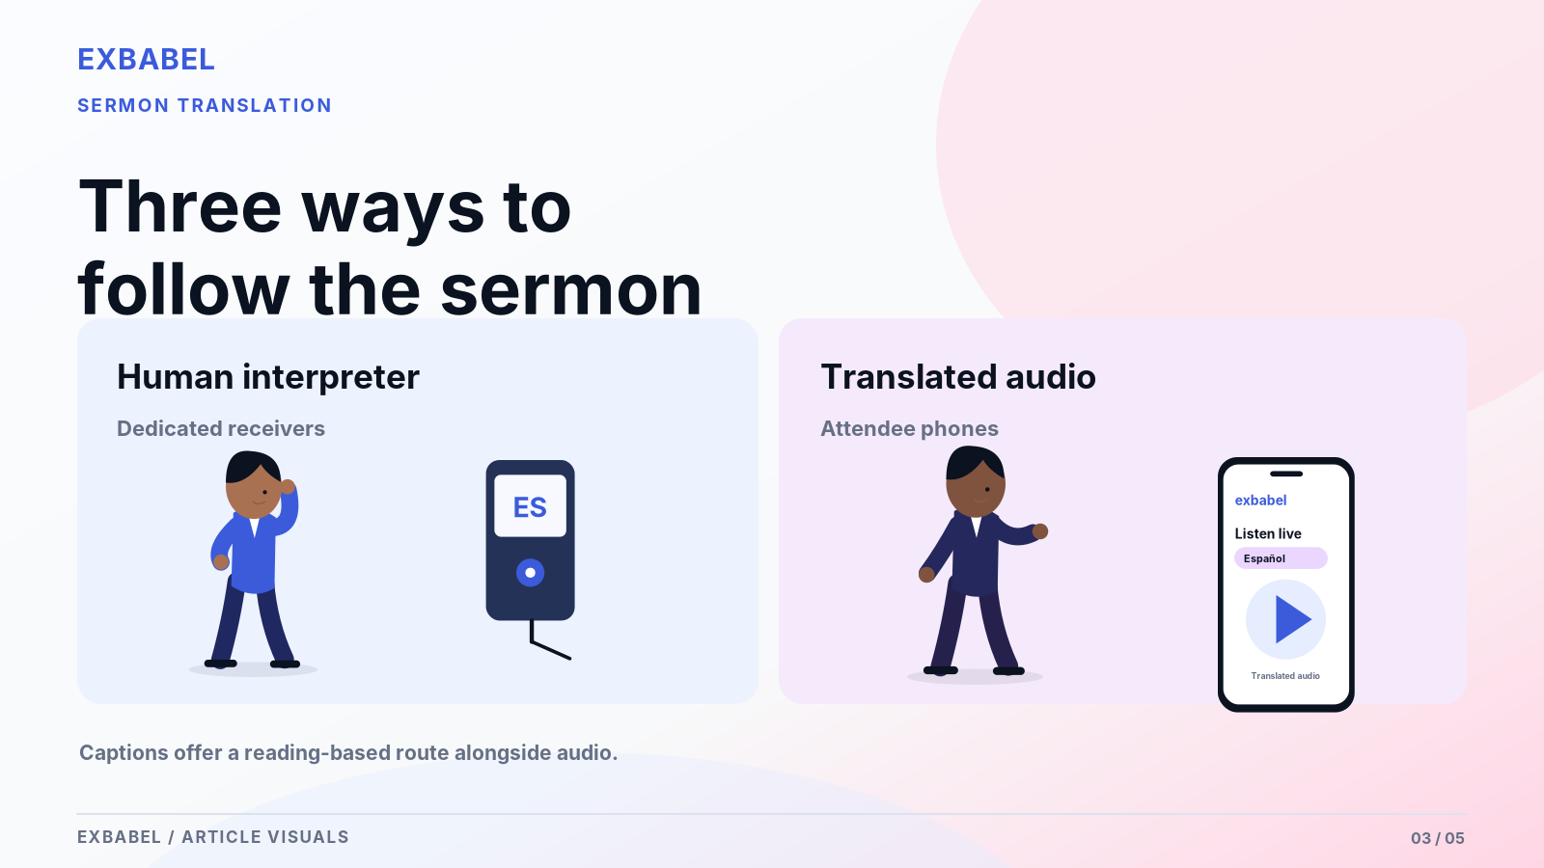
Route | Works best when | What the listener needs
Human interpreter into receivers | One main second language and a dependable interpreter | A borrowed receiver and headphones
AI-translated audio on phones | Several languages or rotating visitors | A phone, earbuds and a QR scan
Captions | Listeners who prefer reading or can't wear earbuds | A phone or a side screen

Human Interpreter into Receiver Channels
One bilingual volunteer interprets into a headset microphone. A transmitter sends that voice out and listeners wear receivers tuned to the channel. You get real nuance on Scripture and tone and you need no internet. The catch is logistics, because somebody must interpret every week and somebody else must babysit the batteries. Our church interpreter vs AI translation comparison lays out the full trade-off.

AI Translated Audio on Attendee Phones
Here software does the interpreting. The pastor's feed goes in and translated speech comes out in whichever language each listener picked. Listeners scan a QR code, put in earbuds and listen. According to Exbabel's how-it-works page, no receivers are involved and no account is needed. You still own the unglamorous parts: a clean mic feed and a steady connection. Verify language and voice options on your plan first.

Captions for Those Who Prefer Reading
Some people read faster than they listen and others can't stand earbuds in a pew. Translated text on a phone or a side screen solves both problems. Deaf and hard-of-hearing worshippers benefit too, though captions never replace a qualified sign-language interpreter. Keep lines short and type big, then check the size from the back row. Exbabel's guide notes that captions may cover more languages than AI voice.

What You Need Before You Begin
The gear list is shorter than you'd think. The table below shows a lean setup beside a staffed one. Each row flags what's unavoidable, optional or plan-dependent.

Speech Input and Compatible Computer
Your translation system hears only what you hand it so the speech source is your first real purchase. A small church can start with one decent microphone plugged into a laptop. A bigger team should ask the mixer for an isolated feed. Either way, you need a computer running the host page in a current browser. Check browser and operating system support on your plan before Sunday.

Internet and Attendee Devices
AI translation leans on a steady connection and the sending computer matters most. Test it right at the sound desk, not in the office down the hall. Can you run an Ethernet cable? Do it, because wired usually beats church Wi-Fi. Listeners can use the church network or their own data plan. Some visitors will forget earbuds so stash a basket of cheap wired pairs by the welcome desk.

Language Selection, Privacy and Fallback
Languages come first and gear comes second. Ask your visitors what they speak instead of guessing, then check which languages your plan supports. If a cloud service processes the audio, tell the congregation plainly. Last, build a plan B on paper: a bilingual usher or printed sermon notes can cover a dropped connection. Run that plan once out loud, since nobody should improvise on Sunday morning.
Item | Lean setup | Staffed setup | Status
Speech source | One suitable microphone into the computer | Isolated pastor feed from the mixer | Unavoidable
Computer | Laptop with a current browser | Dedicated computer at the sound desk | Unavoidable
Connection | Stable internet | Wired Ethernet where possible | Unavoidable
Audio interface | Not needed if the mic connects directly | USB interface or mixer with native USB | Depends on the mixer
Listener devices | Attendee phones and earbuds | Same, plus a few loaner earbuds | Optional extras
Languages and voices | Depends on current plan | Depends on current plan | Verify on plan page
Fallback | Bilingual usher or printed notes | Second operator and a hotspot | Strongly advised

Step 1: Capture a Clean Pastor Microphone Feed
Bad input ruins good translation and no algorithm rescues a muffled mic or a humming amp. So we start at the pastor's microphone and work forward from there.
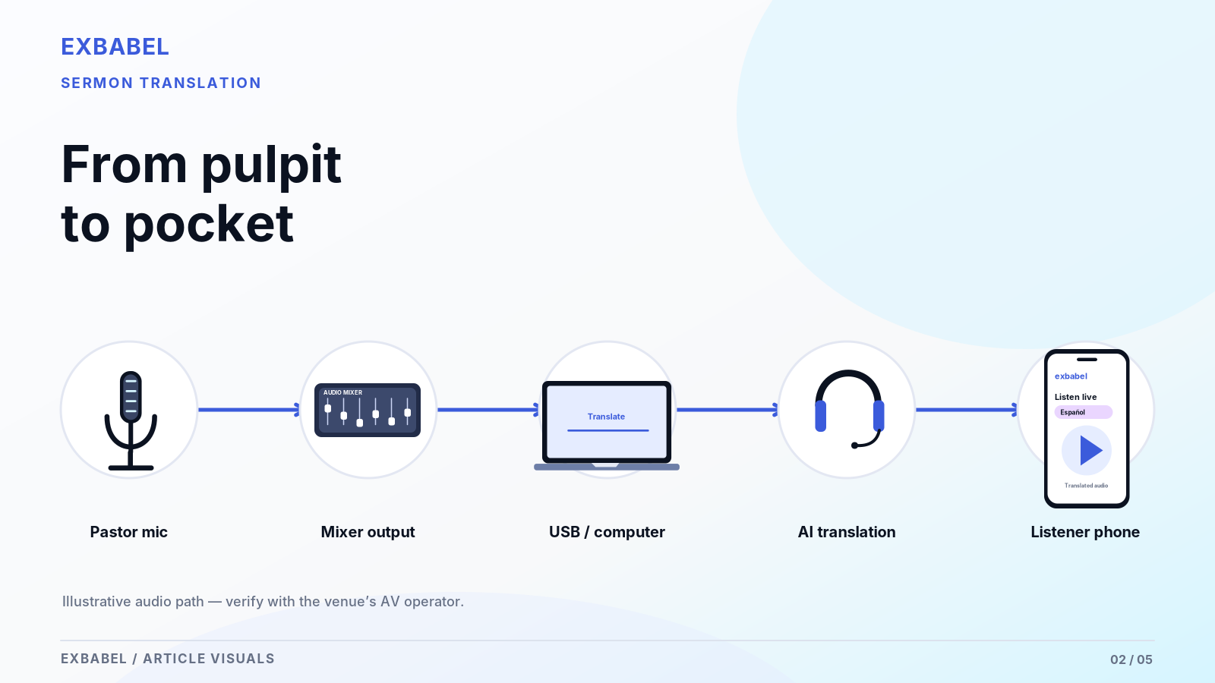

AUX/Matrix vs Main Mix
The main mix carries everything, music included, which makes it a poor source for translation. Ask your sound engineer for a speech-only output from an auxiliary or matrix bus. That keeps the pastor's voice front and center, while drums and keyboards stay out of the feed. If you can't isolate the voice, you can still proceed. Just expect weaker results during songs and plan around them.

Mixer to USB Interface or Verified Native USB
How does that feed reach the computer? Many digital mixers offer native USB audio, while others need a separate USB audio interface with a line-level input. Read the manual first and spend money second. Match the connectors and signal levels, then check that the computer lists the device as an input. Exbabel's church translation system guide describes mixer and USB input as a supported workflow, though your chain may differ.

Gain Staging and Clipping
Gain staging sounds fancy but it only means controlling how loud the signal is as it enters each device. Too hot and the audio clips into harsh distortion. Too quiet and the software hears mush. ProSoundWeb's gain-structure guide advises backing off 10 to 15 dB from clipping. Set levels during rehearsal then tape down the knobs, because curious hands love a shiny dial. Re-check them whenever the pastor swaps microphones.

Step 2: Configure the Live Translation Session
With clean audio in hand, open the host side of the tool. Screens change between versions and plans so treat the notes below as a rough map rather than a script.

Host Audio Input and Source Language
Open the host page and choose the audio input that carries your pastor feed, not the laptop's built-in mic. Then tell the tool which language the pastor really speaks. Does your pastor ever drift into Spanish mid-sermon? Test that separately. Say a few sentences and watch for signs the input is live, then invite people in. Jot your settings down for the next operator.

Choose the Languages and Output Types
Start with the languages your congregation actually needs, not the ones that look impressive on a poster. Audio suits listeners who struggle to read in a second language, while captions suit people who'd rather read. Offer both if your plan allows it. Nobody scrolls a forty-item language menu so a handful of well-tested languages wins. Confirm each language and output on your plan before you promise anything.

Confirm Captions and Audio with a Second Device
Never trust the host screen alone. Grab a phone, join as a listener with earbuds in and check that the translated audio starts. Do the captions match the language you picked? Then walk to the back row and listen again. Better yet, hand the phone to a first-timer and watch their face. A second device shows what visitors actually get and it catches permission pop-ups the host computer never shows.

Step 3: Get Worshippers Connected
The best translation does nothing if visitors can't find it. So make joining ridiculously simple. Think of a first-timer scanning one-handed with a coffee in the other.
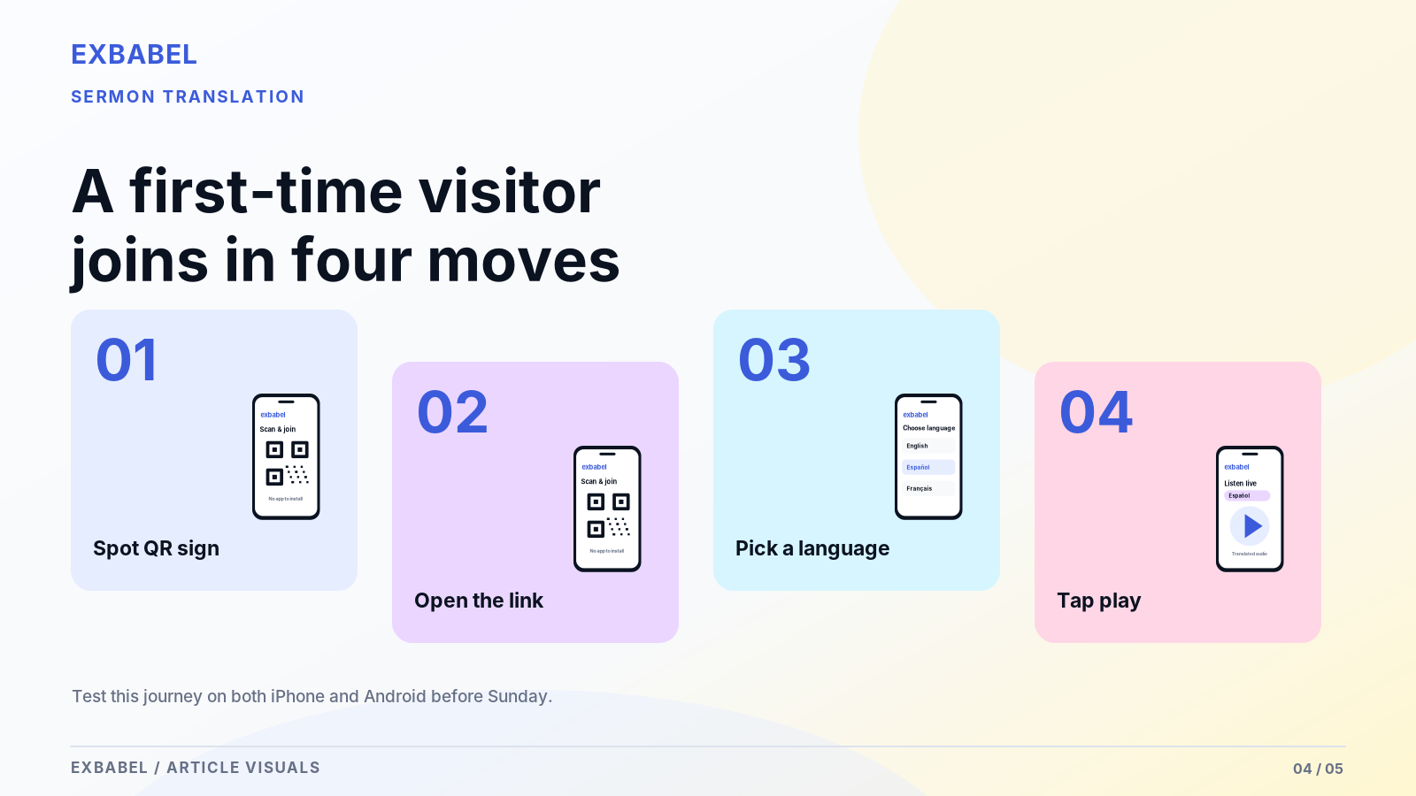

QR Signage and Short Links
Print the QR code bigger than feels reasonable and put it where people loiter, like the lobby and the seat backs. A short link underneath helps anyone whose camera sulks. Announce it from the stage in every language you serve. Test the printed code from three feet away before you laminate a hundred copies. Our church translation apps guide covers joining methods in depth.

Earbud Use Without App Downloads
Exbabel's guide says attendees scan a QR code or open a link in a phone browser, with no native listener app involved. Phone browsers often want a tap before they play sound and WebKit documents this rule for iPhone. That surprises people so tell them before the sermon starts: earbuds in, volume checked. If a language is missing from the list, point visitors to a bilingual usher or printed notes.

In-Room vs Remote Listener Expectations
In-room listeners hear the pastor live and the translation lands a beat later. That gap is normal. Remote viewers live on a different timeline because the stream adds its own buffer so say that early. In-room guests can keep one earbud out to catch the room, while remote guests should mute the original audio. Promise nothing about sub-second timing until you've measured it on your own setup. Honest beats flashy.

Step 4: Rehearse Before Sunday
Rehearsal separates a smooth Sunday from a white-knuckle one. Run a five-minute mini-test with real speech and write down what you hear, because notes beat memory.
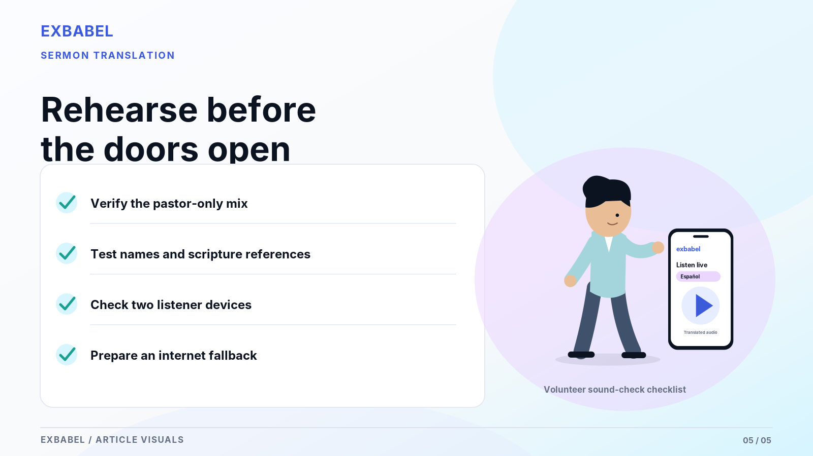

Bible Names, Proper Nouns and Terminology
Scripture makes a brutal stress test. Read a whole passage stuffed with names like Melchizedek and Nebuchadnezzar, then listen to what comes out. Rehearsal stumbles are cheap, while live ones are embarrassing. Add your own vocabulary too, such as ministry and staff names. Ask a bilingual reviewer to flag every slip, keep a running list of problem words and retest after each software or plan change.

Long Phrases, Music Transitions and Rapid Preaching
Pastors don't speak in tidy sentences. Some run long and others pick up speed when the message builds so test both. Include a stretch where the band moves into the sermon, since stray music can muddy the input. Mark where the translation drops words or falls behind and record the session so the team can replay the rough spots. Those moments show where to tighten the mix or brief the preacher.

Latency and Quality Test Log
Record the session on two devices: one captures the source audio and the other captures what a listener hears. Line the recordings up side by side. Only quote a delay figure if you measured it this way. Otherwise describe what you observed in plain terms. Date the recordings and jot down your settings. The table below is your five-minute test, with pass and fail marks.
Step | What to do | Pass | Fail
1. Input | A volunteer reads a five-minute passage through the real pastor mic, with three Scripture references and three proper names | The input is live and the level never clips | Silence, hum or clipping
2. Listener join | Join on a phone with earbuds in one target language | You hear translated audio after one tap | No sound or a blocked permission
3. Captions | Switch captions on at the same time | Correct language and readable from the back row | Wrong language or unreadable text
4. Reviewer | A bilingual reviewer listens to the full test | Meaning holds and names are recognizable | Meaning changes or names are garbled
5. Network | Repeat step 2 on cellular data | Same result as church Wi-Fi | Drops or long gaps
6. Delay | Record source and listener audio together | You can state a measured gap | You can't measure it, so quote no number

Troubleshoot Common Failures
Something will go wrong, because Murphy never takes Sundays off. Learn which symptom points to which cause and tape the checks below to the sound desk.

No Input Audio, Clipping, Silent Output
Start at the source and walk toward the listener. No input at all usually means a muted channel or the wrong input selection, while distorted audio means the gain is too hot. If output is silent while captions keep running, check the listener's volume first. Then look for a browser that never got its tap to play sound. Work through each link in that order, because skipping steps costs more time.

Phone Not Connecting or Delayed Translation
When a phone won't connect, rescan the code and try cellular data instead of church Wi-Fi, since guest networks sometimes block traffic. If the translation lags, check the host computer first. A weak connection or one greedy background task can slow everything down. Close extra browser tabs and test a wired link. Try the simple fixes first and confirm any platform-specific recovery steps against the current app before you print a help card.

Safe Fallback When Service Internet Fails
Plan for the day the internet drops, because it will. A cellular hotspot can take over if you've rehearsed the switch. Your human fallback matters just as much: a bilingual usher or printed sermon notes in your main visitor languages will do. Who makes the call to switch? Name that person now. Then tell the congregation calmly and keep worship moving forward. A short, honest announcement beats a silent room.
Symptom | Likely cause | Next step
No input audio | Muted channel or wrong input selected | Check the mixer channel and the host input selector
Distorted audio | Gain set too hot | Lower the gain and re-test at the loudest preaching
Captions run but audio stays silent | Listener volume or a missing tap-to-play | Raise the volume and tap play again
Phone won't connect | Guest Wi-Fi blocking traffic | Rescan and try cellular data
Translation lags | Weak connection or a busy host computer | Close extra tabs and test a wired link
Everything drops | Internet outage at the venue | Switch to the fallback plan
Test this workflow with your existing church audio setup. Bring your mixer feed or microphone, pick one language pair and run the five-minute test above. Then see how Exbabel supports churches or read how Exbabel works first.

AI, Human or Hybrid: What Changes
No single method wins every Sunday, since funerals and Easter services ask for different things. Match the method to the moment. Here is how we think about it, briefly.

Sensitive Pastoral Interpretation
Some moments call for a person. Funerals and doctrinal teaching carry weight that software may flatten and a trained interpreter reads the room. AI audio also isn't a stand-in for qualified sign-language interpreters, which the Department of Justice's ADA.gov guidance on effective communication lists as a distinct auxiliary aid. If a service hinges on exact theological wording, hire a human interpreter or add a bilingual reviewer.

Regular Weekly Sermons and Multilingual Outreach
Week after week, AI translation lowers the barrier, like a ramp instead of a wall. A visitor joins in their own language without waiting for a volunteer to free up. Smaller language groups that could never justify a full interpreter team get a seat at the table. Pair it with a bilingual member who reviews recordings afterward. That loop sharpens your term list and shows you where a human-led option still matters.

Make Next Sunday Your Test Run
Start small. Put the pastor's voice on a clean feed, grab a second phone and listen like a visitor. Run the five-minute test and fix whatever the log shows. That loop beats most gear upgrades and it costs one rehearsal slot.
- Weighing hardware? Our church translation equipment guide compares receivers with phone-based delivery.
- Deciding between people and software? The interpreter vs AI comparison lays out the trade-offs.
- Want a second pair of ears? Ask a bilingual member to review a recording after service.

Frequently Asked Questions

Can a Sermon Be Translated While the Pastor Is Still Speaking?
Yes. Interpreters do it every Sunday and AI systems can too. Both work while the pastor keeps preaching and both add a short delay. Software may process speech in chunks. Measure the gap in your own room with a recorded test before you quote any number.

Do Visitors Need an App or Dedicated Receivers?
Not with a browser-based system. Per Exbabel's guide, attendees scan a QR code or open a link in a phone browser. Receivers remain a separate hardware route and some people without smartphones still prefer them. Test iPhone and Android browsers during rehearsal.

What Equipment Does a Small Church Need?
A clean pastor microphone feed and a computer on a stable internet connection are the minimum. Listeners bring their own phones and earbuds. A mixer with a speech-only output makes life easier, though it isn't required to start.

What Should We Test with Spanish, Vietnamese and Other Language Variants?
Start with Scripture references and proper names. Then hand the output to a native speaker of your congregation's variant, since Spanish in Mexico isn't Spanish in Spain. Check that each language and voice appears on your current plan before you promise it.

How Should a Church Recover if Captions Continue but Translated Audio Stops?
Check the listener's volume and the tap-to-play prompt first. Next, reload the listener page and rejoin the language. If there's still no audio, keep captions running and send affected listeners to a bilingual usher. Confirm the exact recovery flow in the current app before you print it.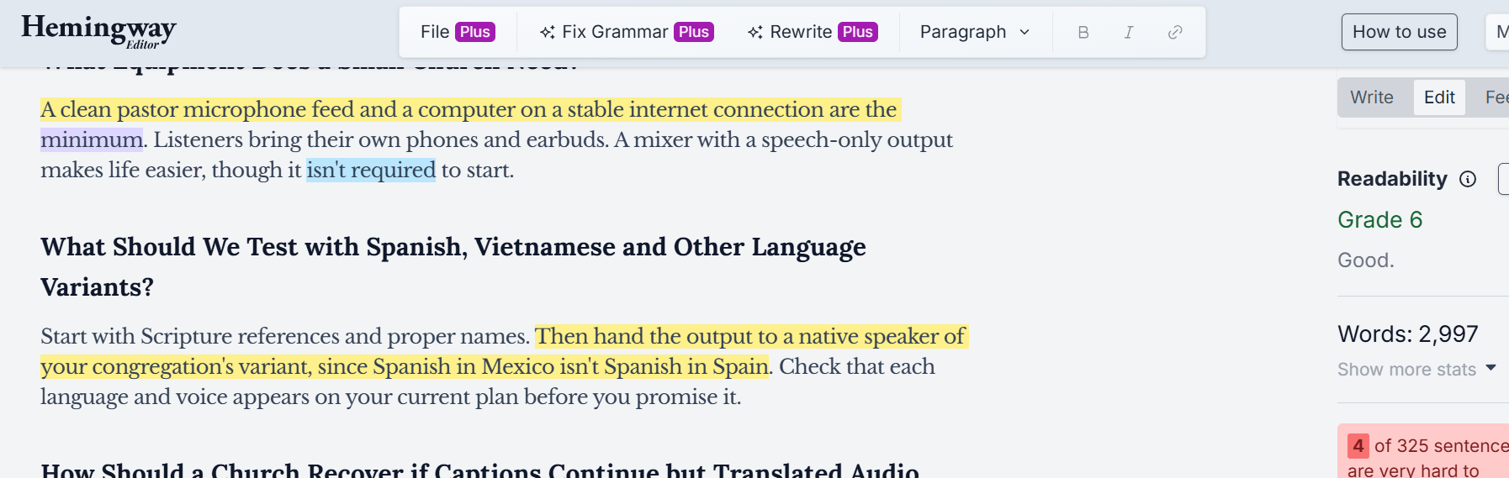
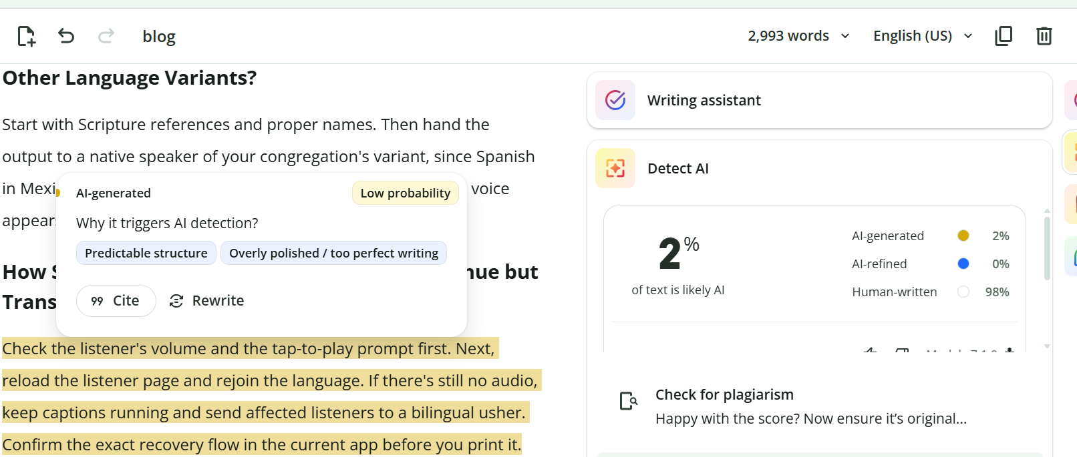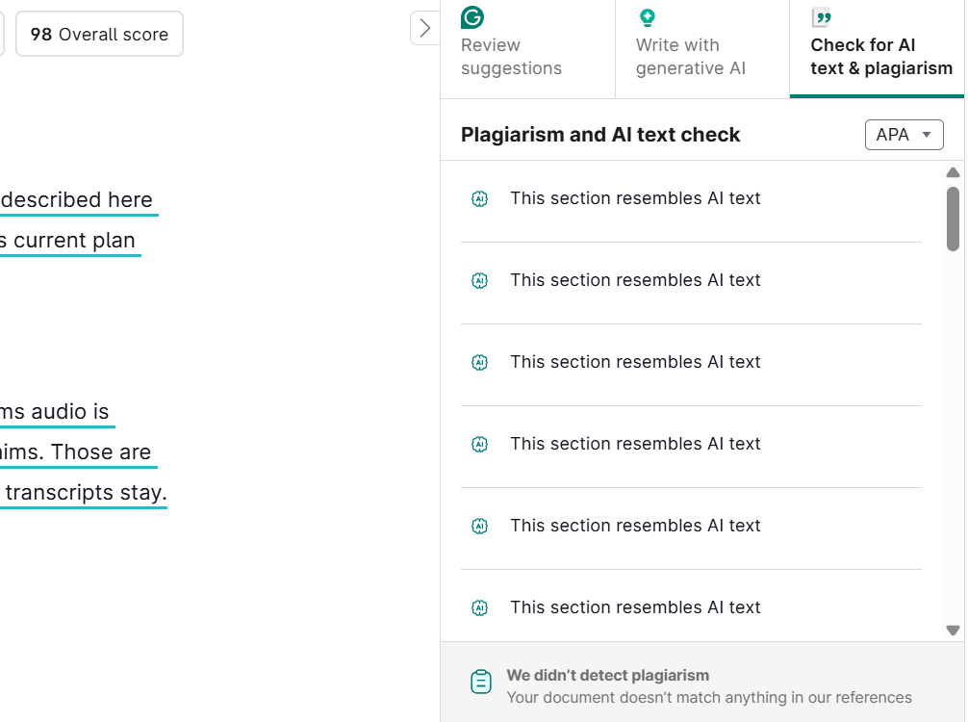

SEO METADATA
- SEO title (58 chars): Sermon Translation: How to Translate Church Services Live
- Meta description: Learn how to translate sermons live using a church mixer, USB audio input, multilingual captions, and listener QR codes. Includes a Sunday testing checklist.
- URL slug: /blog/sermon-translation-guide/
- Primary keyword: sermon translation
- Unique primary search intent: Implementation. "How do I set up live sermon translation, from the pastor's microphone to the listener's phone?" Product selection belongs to the church landing page (https://exbabel.com/solutions/churches/). System comparison belongs to /blog/church-translation-system/. Joining methods belong to /blog/church-translation-apps/.
- Secondary phrases used naturally: live sermon translation, how to translate sermons, translate church service live, church audio translation, sermon translation software, Spanish sermon captions, multilingual worship services
- Author disclosure: Published by Exbabel.
- Suggested schema: Article + FAQPage (use the FAQ items below).
Further reading (external, descriptive anchors):
- Census Bureau on language spoken at home: the population figure used in the introduction.
- ProSoundWeb on gain staging: headroom and clipping basics.
- WebKit on iOS media playback: why sound needs a tap on iPhone.
- ADA.gov on effective communication: auxiliary aids, including qualified interpreters.
Published by Exbabel.

IMAGE AND RESOURCE RECOMMENDATIONS (with alt text)
- Four-stage signal-flow diagram (mixer, interface, Exbabel, listener phone), marked illustrative until technically checked. Alt: "Diagram showing the pastor's microphone feeding a mixer, a USB interface, a translation tool and a listener's phone."
- Annotated screenshots with version and date: host input selector, language choice, QR join, listener captions and translated audio.
- Printable Sunday sound-check worksheet with a 10-step test and a failure-response card.
- Photo of a QR sign near the sanctuary door (original, with permission).

SOURCE LOG (accessed October 18, 2026)
Source | URL | Used for | Claim type
Census Bureau, language at home (2018 to 2022) | https://www.census.gov/newsroom/press-releases/2023/language-at-home-acs-5-year.html | 21.7% figure | Government data
ProSoundWeb gain-structure article | https://www.prosoundweb.com/setting-sound-system-and-mixing-console-gain-staging/ | Headroom, backing off 10 to 15 dB from clipping | Trade publication
WebKit: New Video Policies for iOS (July 25, 2016) | https://webkit.org/blog/6784/new-video-policies-for-ios/ | Sound needs a user gesture on iOS Safari | Platform documentation (dated; re-verify)
ADA.gov effective communication | https://www.ada.gov/resources/effective-communication/ | Qualified interpreters as a distinct auxiliary aid | Government guidance (context only)
Exbabel how-it-works | https://exbabel.com/how-it-works/ | QR or link, no app or account, mixer input | Exbabel page
Exbabel church translation system guide | https://www.exbabel.com/blog/church-translation-system/ | Mixer and USB input, Chrome mention, captions may cover more languages | Exbabel documentation (re-verify)
Exbabel Top 7 Expanded SEO Editorial Briefs (Brief 01) | Client brief | Outline, guardrails, CTA rule | Client brief
Deliberately not used: any latency figure; any universal mixer menu sequence; any language-count or listener-limit claim; any claim that AI replaces sign-language interpreting; competitor pages (Hope Translator, Maestra, Wordly) as links, per the instruction to keep external links non-competitor.

VERIFICATION CHECKLIST
- Add the named mixer, browser, device, language pair and network from the demonstration, as the brief requires.
- Attach the host-page screenshots with version and date.
- Confirm the "no account needed", Chrome and "captions may cover more languages" statements against the live guide.
- Confirm /blog/church-interpreter-vs-ai-translation/, /blog/church-translation-system/, /blog/church-translation-equipment/ and /blog/church-translation-apps/ are live.
- Confirm the CTA destinations (church page and how-it-works).
- Have a bilingual reviewer check the scripture-name test.

